//APP CONFIG

package com.cognizant.spring_learn.config;  
import org.springframework.context.annotation.Bean;  
import org.springframework.context.annotation.Configuration;  
import java.text.SimpleDateFormat;  
@Configuration  
public class AppConfig {  
 @Bean  
 public SimpleDateFormat dateFormat() {  
 return new SimpleDateFormat("dd/MM/yyyy");  
 }  
}

//Date Controller

package com.cognizant.spring_learn.Controller;  
  
import com.cognizant.spring_learn.Model.DateModel;  
import com.cognizant.spring_learn.Service.DateService;  
import org.springframework.beans.factory.annotation.Autowired;  
import org.springframework.web.bind.annotation.*;  
  
@RestController  
@RequestMapping("/api/date")  
public class DateController {  
 @Autowired  
 private DateService dateService;  
 @GetMapping("/parse")  
 public DateModel parseDate(@RequestParam String dateStr) {  
 return new DateModel(dateStr, dateService.parseDate(dateStr));  
 }  
}

//Date Model

package com.cognizant.spring_learn.Model;  
import java.util.Date;  
public class DateModel {  
 private String inputDate;  
 private Date parsedDate;  
 public DateModel() {}  
 public DateModel(String inputDate, Date parsedDate) {  
 this.inputDate = inputDate;  
 this.parsedDate = parsedDate;  
 }  
  
 public String getInputDate() {  
 return inputDate;  
 }  
  
 public void setInputDate(String inputDate) {  
 this.inputDate = inputDate;  
 }  
  
 public Date getParsedDate() {  
 return parsedDate;  
 }  
 public void setParsedDate(Date parsedDate) {  
 this.parsedDate = parsedDate;  
 }  
}

//Service Class

package com.cognizant.spring_learn.Service;  
import org.slf4j.Logger;  
import org.slf4j.LoggerFactory;  
import org.springframework.beans.factory.annotation.Autowired;  
import org.springframework.stereotype.Service;  
import java.text.SimpleDateFormat;  
import java.util.Date;  
@Service  
public class DateService {  
 private static final Logger *LOGGER* = LoggerFactory.*getLogger*(DateService.class);  
 private SimpleDateFormat dateFormat;  
 @Autowired  
 public void setDateFormat(SimpleDateFormat dateFormat) {  
 this.dateFormat = dateFormat;  
 }  
 public Date parseDate(String dateStr) {  
 *LOGGER*.debug("Parsing date string: {}", dateStr);  
 try {  
 return dateFormat.parse(dateStr);  
 } catch (Exception e) {  
 *LOGGER*.error("Date parsing failed for: {}", dateStr);  
 throw new RuntimeException("Invalid date format: " + dateStr, e);  
 }  
 }  
}

//Main Class

package com.cognizant.spring_learn;  
  
import com.cognizant.spring_learn.Service.DateService;  
import org.springframework.boot.SpringApplication;  
import org.springframework.boot.autoconfigure.SpringBootApplication;  
import org.springframework.context.ApplicationContext;  
import org.slf4j.Logger;  
import org.slf4j.LoggerFactory;  
import java.text.SimpleDateFormat;  
import java.util.Date;  
@SpringBootApplication  
public class SpringLearnApplication {  
 private static final Logger *LOGGER* = LoggerFactory.*getLogger*(SpringLearnApplication.class);  
 public static void main(String[] args) {  
 ApplicationContext context = SpringApplication.*run*(SpringLearnApplication.class, args);  
 *displayDate*(context);  
 }  
 public static void displayDate(ApplicationContext context) {  
 *LOGGER*.info("START");  
 SimpleDateFormat format = context.getBean(SimpleDateFormat.class);  
 DateService dateService = context.getBean(DateService.class);  
 Date parsed = dateService.parseDate("31/12/2018");  
 *LOGGER*.debug("Parsed Date: {}", parsed);  
 *LOGGER*.info("END");  
 }  
}

//dateformat.xml

<?xml version="1.0" encoding="UTF-8"?>  
<beans xmlns="http://www.springframework.org/schema/beans"  
 xmlns:xsi="http://www.w3.org/2001/XMLSchema-instance"  
 xsi:schemaLocation="http://www.springframework.org/schema/beans  
 https://www.springframework.org/schema/beans/spring-beans.xsd">  
  
 <bean id="dateFormat" class="java.text.SimpleDateFormat">  
 <constructor-arg value="dd/MM/yyyy" />  
 </bean>  
</beans>

//Output

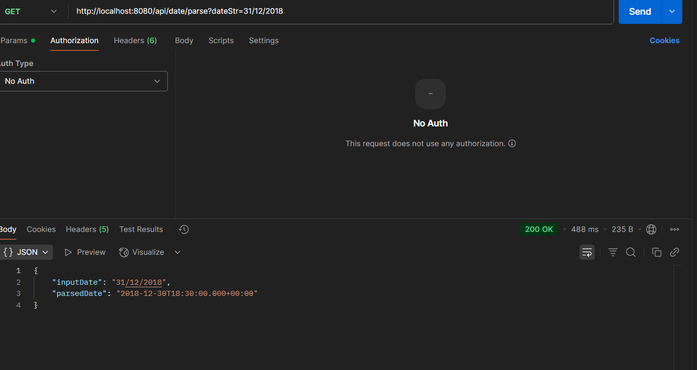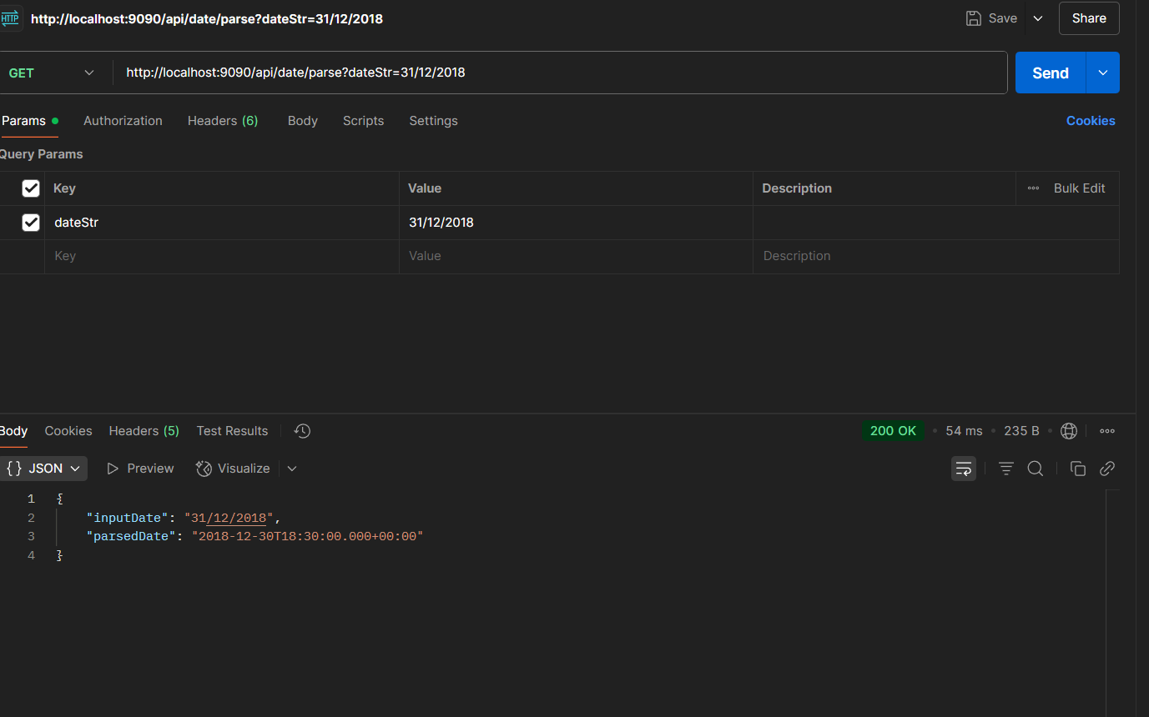

///Country class

package com.cognizant.spring_learn.Model;  
public class Country {  
 private String code;  
 private String name;  
 public Country() {}  
 public String getCode() {  
 return code;  
 }  
 public void setCode(String code) {  
 this.code = code;  
 }  
 public String getName() {  
 return name;  
 }  
 public void setName(String name) {  
 this.name = name;  
 }  
 @Override  
 public String toString() {  
 return "Country{" + "code='" + code + '\'' + ", name='" + name + '\'' + '}';  
 }  
}

//Country Controller

package com.cognizant.spring_learn.Controller;  
import com.cognizant.spring_learn.Model.Country;  
import org.springframework.context.ApplicationContext;  
import org.springframework.context.support.ClassPathXmlApplicationContext;  
import org.springframework.web.bind.annotation.*;  
import java.util.List;  
@RestController  
@RequestMapping("/countries")  
public class CountryController {  
 @GetMapping("/single")  
 public Country getCountry() {  
 ApplicationContext context = new ClassPathXmlApplicationContext("country.xml");  
 return context.getBean("in", Country.class);  
 }  
 @GetMapping("/all")  
 public List<Country> getAllCountries() {  
 ApplicationContext context = new ClassPathXmlApplicationContext("country.xml");  
 return (List<Country>) context.getBean("countryList");  
 }  
}

//Main Class

package com.cognizant.spring_learn;

import org.springframework.boot.SpringApplication;

import org.springframework.boot.autoconfigure.SpringBootApplication;

@SpringBootApplication

public class SpringLearnApplication {

public static void main(String[] args) {

SpringApplication.run(SpringLearnApplication.class, args);

}

}

//Country.xml

<?xml version="1.0" encoding="UTF-8"?>  
<beans xmlns="http://www.springframework.org/schema/beans"  
 xmlns:xsi="http://www.w3.org/2001/XMLSchema-instance"  
 xsi:schemaLocation="http://www.springframework.org/schema/beans  
 https://www.springframework.org/schema/beans/spring-beans.xsd">  
  
 <bean id="in" class="com.cognizant.spring_learn.Model.Country">  
 <property name="code" value="IN"/>  
 <property name="name" value="India"/>  
 </bean>  
  
 <bean id="us" class="com.cognizant.spring_learn.Model.Country">  
 <property name="code" value="US"/>  
 <property name="name" value="United States"/>  
 </bean>  
  
 <bean id="de" class="com.cognizant.spring_learn.Model.Country">  
 <property name="code" value="DE"/>  
 <property name="name" value="Germany"/>  
 </bean>  
  
 <bean id="jp" class="com.cognizant.spring_learn.Model.Country">  
 <property name="code" value="JP"/>  
 <property name="name" value="Japan"/>  
 </bean>  
  
 <bean id="countryList" class="java.util.ArrayList">  
 <constructor-arg>  
 <list>  
 <ref bean="in"/>  
 <ref bean="us"/>  
 <ref bean="de"/>  
 <ref bean="jp"/>  
 </list>  
 </constructor-arg>  
 </bean>  
  
</beans>

///Output

